# **Exercise 2**

## PersonList.js

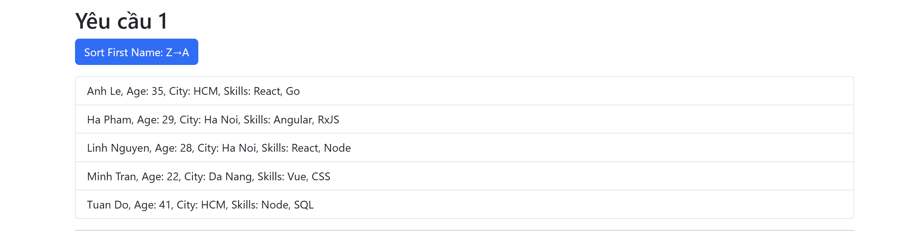

import React, { useState } from 'react';

import { persons } from '../persons';

import { Button, ListGroup } from 'react-bootstrap';

const PersonList = () => {

  const [sortedPersons, setSortedPersons] = useState([...persons]); // Sao chép mảng ban đầu

  const [sortAsc, setSortAsc] = useState(true);

  const handleSort = () => {

    const sorted = [...sortedPersons].sort((a, b) => {

      const compareResult = a.firstName.localeCompare(b.firstName);

      return sortAsc ? compareResult : -compareResult; // Đảo ngược bằng cách nhân -1

    });

    setSortedPersons(sorted);

    setSortAsc(!sortAsc);

  };

  return (

    <div>

      <Button variant="primary" onClick={handleSort} className="mb-3">

        Sort First Name: {sortAsc ? 'A→Z' : 'Z→A'}

      </Button>

      <ListGroup>

        {sortedPersons.map(p => (

          <ListGroup.Item key={p.id}>

            {`${p.firstName} ${p.lastName}, Age: ${p.age}, City: ${p.city}, Skills: ${p.skills.join(', ')}`}

          </ListGroup.Item>

        ))}

      </ListGroup>

    </div>

  );

};

export default PersonList;

## FilterPersons.js

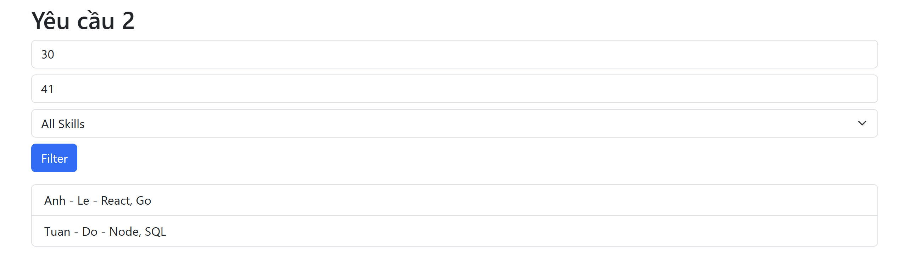

import React, { useState } from 'react';

import { persons } from '../persons';

import { Form, Button, ListGroup } from 'react-bootstrap';

const FilterPersons = () => {

  const [minAge, setMinAge] = useState('');

  const [maxAge, setMaxAge] = useState('');

  const [selectedSkill, setSelectedSkill] = useState('');

  const [filtered, setFiltered] = useState([]);

  const skills = persons.reduce((acc, { skills }) => [...acc, ...skills], []).filter((v, i, a) => a.indexOf(v) === i);

  const handleFilter = () => {

    const result = persons.filter(({ age, skills }) => {

      const inAge = (!minAge || age >= +minAge) && (!maxAge || age <= +maxAge);

      const hasSkill = !selectedSkill || skills.includes(selectedSkill);

      return inAge && hasSkill;

    });

    setFiltered(result);

  };

  return (

    <div>

      <Form className="mb-3">

        <Form.Group className="mb-2">

          <Form.Control

            type="number"

            placeholder="Min Age"

            value={minAge}

            onChange={e => setMinAge(e.target.value)}

          />

        </Form.Group>

        <Form.Group className="mb-2">

          <Form.Control

            type="number"

            placeholder="Max Age"

            value={maxAge}

            onChange={e => setMaxAge(e.target.value)}

          />

        </Form.Group>

        <Form.Group className="mb-2">

          <Form.Select value={selectedSkill} onChange={e => setSelectedSkill(e.target.value)}>

            <option value="">All Skills</option>

            {skills.map(s => <option key={s} value={s}>{s}</option>)}

          </Form.Select>

        </Form.Group>

        <Button variant="primary" onClick={handleFilter}>

          Filter

        </Button>

      </Form>

      {filtered.length ? (

        <ListGroup>

          {filtered.map(({ firstName, lastName, skills }) => (

            <ListGroup.Item key={firstName}>{`${firstName} - ${lastName} - ${skills.join(', ')}`}</ListGroup.Item>

          ))}

        </ListGroup>

      ) : <p className="text-center text-muted">No found.</p>}

    </div>

  );

};

export default FilterPersons;

## SkillRanking.js

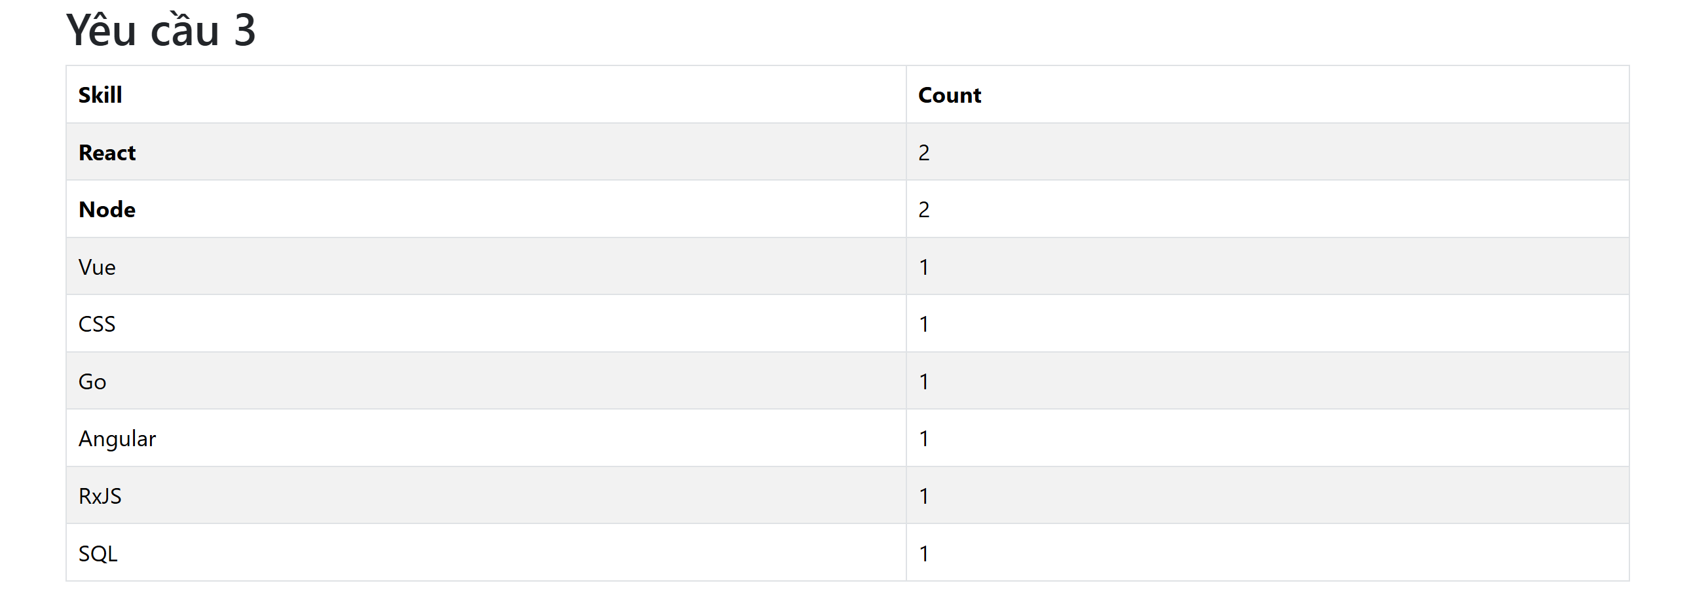

import React from 'react';

import { persons } from '../persons';

import { Table } from 'react-bootstrap';

const SkillRanking = () => {

  const skillCounts = persons.reduce((acc, { skills }) => {

    skills.forEach(s => acc[s] = (acc[s] || 0) + 1);

    return acc;

  }, {});

  const sortedSkills = Object.entries(skillCounts).sort(([,a], [,b]) => b - a);

  const maxCount = sortedSkills[0]?.[1] || 0;

  return (

    <Table striped bordered hover>

      <thead>

        <tr>

          <th>Skill</th>

          <th>Count</th>

        </tr>

      </thead>

      <tbody>

        {sortedSkills.map(([skill, count]) => (

          <tr key={skill}>

            <td style={{ fontWeight: count === maxCount ? 'bold' : 'normal' }}>{skill}</td>

            <td>{count}</td>

          </tr>

        ))}

      </tbody>

    </Table>

  );

};

export default SkillRanking;

## SearchPersons.js

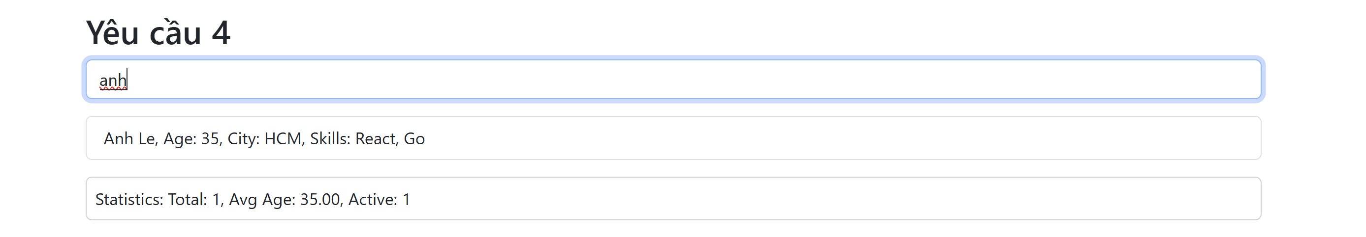

import React, { useState, useEffect } from 'react';

import { persons } from '../persons';

import { Form, ListGroup, Card } from 'react-bootstrap';

const SearchPersons = () => {

  const [searchTerm, setSearchTerm] = useState('');

  const [displayed, setDisplayed] = useState(persons);

  useEffect(() => {

    let filtered = persons.filter(p => `${p.firstName} ${p.lastName}`.toLowerCase().includes(searchTerm.toLowerCase()));

    filtered.sort((a, b) => {

      if (a.isActive !== b.isActive) return b.isActive - a.isActive ? 1 : -1;

      if (a.age !== b.age) return a.age - b.age;

      return a.lastName.localeCompare(b.lastName);

    });

    setDisplayed(filtered);

  }, [searchTerm]);

  const stats = displayed.reduce((acc, { age, isActive }) => {

    acc.total++;

    acc.sumAge += age;

    if (isActive) acc.active++;

    return acc;

  }, { total: 0, sumAge: 0, active: 0 });

  const avgAge = stats.total ? (stats.sumAge / stats.total).toFixed(2) : 0;

  return (

    <div>

      <Form.Group className="mb-3">

        <Form.Control

          type="text"

          placeholder="Search by name"

          value={searchTerm}

          onChange={e => setSearchTerm(e.target.value)}

        />

      </Form.Group>

      <ListGroup>

        {displayed.map(p => (

          <ListGroup.Item key={p.id}>{`${p.firstName} ${p.lastName}, Age: ${p.age}, City: ${p.city}, Skills: ${p.skills.join(', ')}`}</ListGroup.Item>

        ))}

      </ListGroup>

      <Card className="mt-3 p-2">

        <Card.Text>Statistics: Total: {stats.total}, Avg Age: {avgAge}, Active: {stats.active}</Card.Text>

      </Card>

    </div>

  );

};

export default SearchPersons;

## App.js

import React from 'react';

import PersonList from './components/PersonList';

import FilterPersons from './components/FilterPersons';

import SkillRanking from './components/SkillRanking';

import SearchPersons from './components/SearchPersons';

import { Container } from 'react-bootstrap';

function App() {

  return (

    <Container className="my-4">

      <h1 className="mb-4">Bài tập React</h1>

      <h2>Yêu cầu 1</h2>

      <PersonList />

      <hr />

      <h2>Yêu cầu 2</h2>

      <FilterPersons />

      <hr />

      <h2>Yêu cầu 3</h2>

      <SkillRanking />

      <hr />

      <h2>Yêu cầu 4</h2>

      <SearchPersons />

    </Container>

  );

}

export default App;